**Feature Extraction**

Feature extraction is the process of transforming raw data into a set of features that better represent the underlying patterns or characteristics of the data. It plays a critical role in machine learning and data analysis, as it reduces the dimensionality and complexity of the data while retaining essential information. This step makes the data more suitable for building predictive models and analysis.

### ****Feature Extraction Techniques****

There are so many feature extraction techniques that are commonly used, here is some of them:

**1. Image Features**

* **Color Features**: RGB values, Histograms, Color Moments.
* **Texture Features**: GLCM, LBP, Gabor Filters.
* **Shape Features**: Contours, Edges, HOG (Histogram of Oriented Gradients).
* **Keypoint Features**: SIFT, ORB, SURF.

**2. Text Features**

* Bag of Words (BoW).
* Term Frequency-Inverse Document Frequency (TF-IDF).
* Word Embeddings (e.g., Word2Vec, GloVe).

**3. Audio Features**

* Mel-Frequency Cepstral Coefficients (MFCC).
* Spectrograms.

**4. Time Series Features**

* Statistical features (mean, standard deviation).
* Frequency domain features (FFT).

**Features used in the Project:**

1. **Install Packages:**



1. **Import Libraries:**

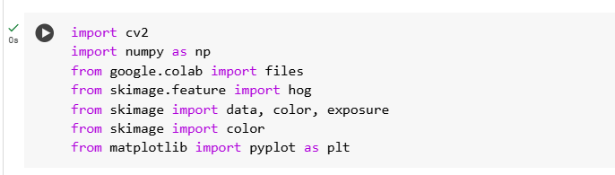

1. **Upload The Image:**



1. **Load and Convert The Image:**



1. **Visualizing The RGB Image:**

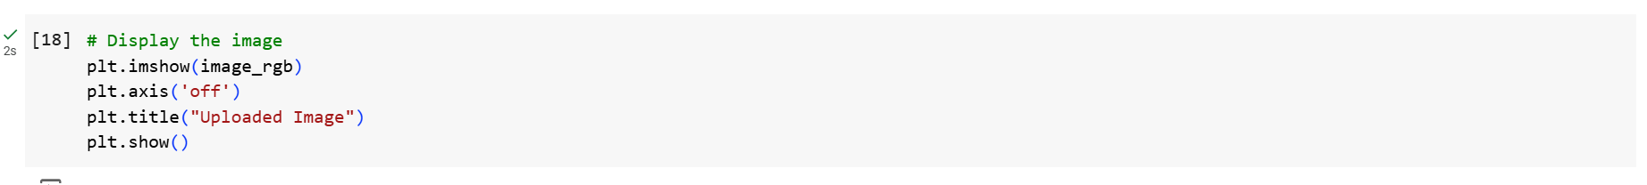

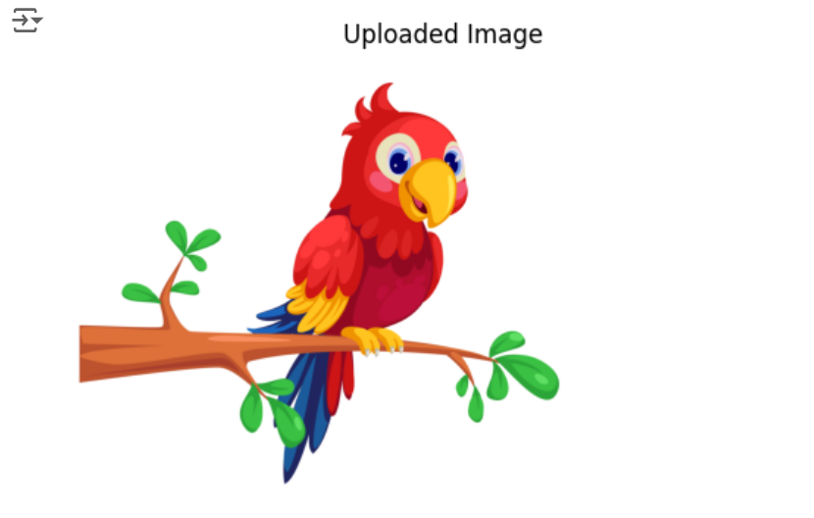

**1. RGB Color Feature Extraction**

RGB color feature extraction focuses on analyzing the distribution of the primary colors - Red, Green, and Blue - in an image. Each pixel in an image has three components corresponding to these colors. The goal of RGB feature extraction is to capture the average color values and the spread (variance) of each channel.

This feature extraction technique is often used in tasks like color-based image retrieval or categorization, as it helps identify the overall color composition of an image.

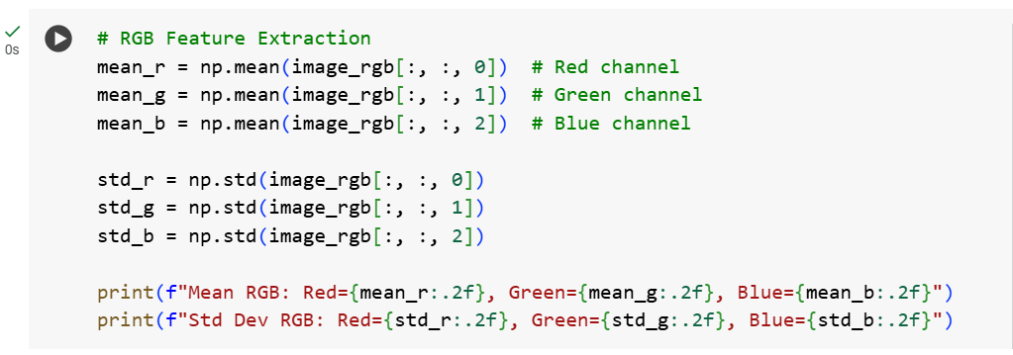

**Output:**



**2. Color Histogram**

The color histogram is a representation of the distribution of pixel intensities for each color channel (Red, Green, and Blue) in an image. The histogram is created by counting the number of pixels that fall into different intensity bins for each channel.

Color histograms are frequently used for image classification, retrieval, and analysis, particularly when the spatial location of colors is not important, but their distribution is.

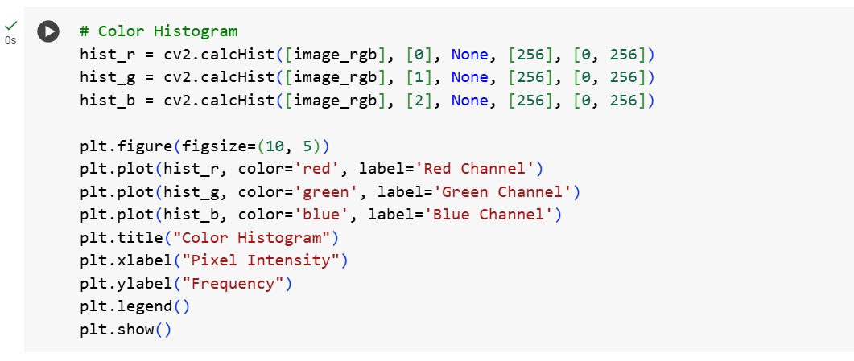

**Output:**

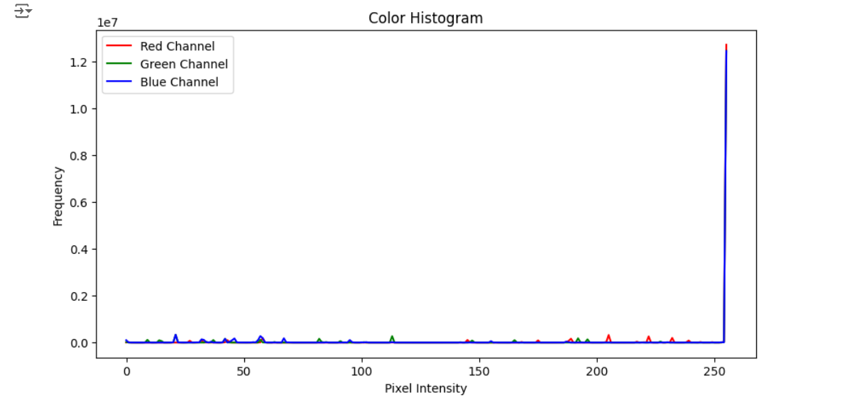

**3. HOG (Histogram of Oriented Gradients)**

HOG is a feature extraction method used to detect the structure and edges of an object within an image. It works by capturing the gradient magnitude and direction over small regions of an image and is particularly effective in detecting shapes, textures, and edges.

HOG is commonly used in object detection tasks, particularly for human detection, and is often used in combination with machine learning models like Support Vector Machines (SVM) for classification.

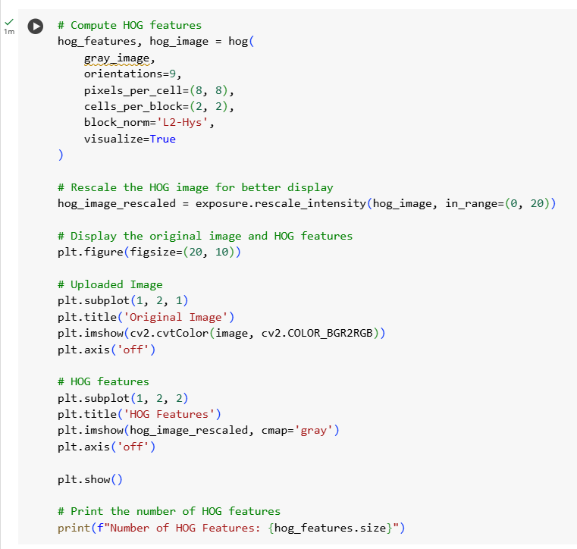

**Output:**

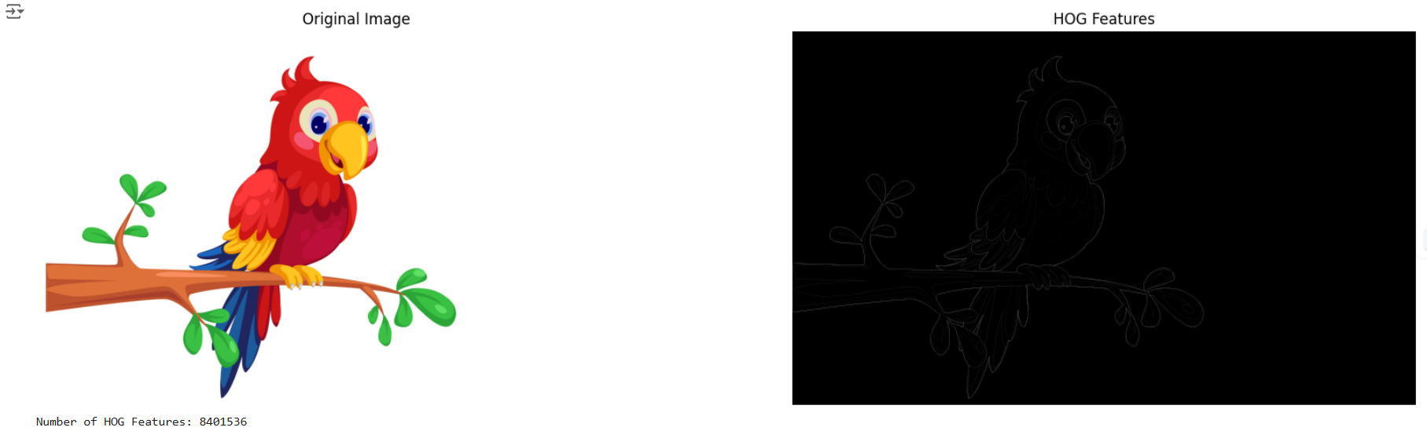

**4. ORB (Oriented FAST and Rotated BRIEF)**

ORB (Oriented FAST and Rotated BRIEF) is a feature extraction technique designed to identify key points in an image and describe them in a way that is invariant to rotation and scale. It is an efficient alternative to traditional methods like SIFT and SURF and is particularly useful in tasks such as object recognition and matching.

This feature extraction technique is widely used for applications such as **object recognition**, **image matching**, and **motion tracking**. Its efficiency and robustness make it suitable for real-time image analysis.

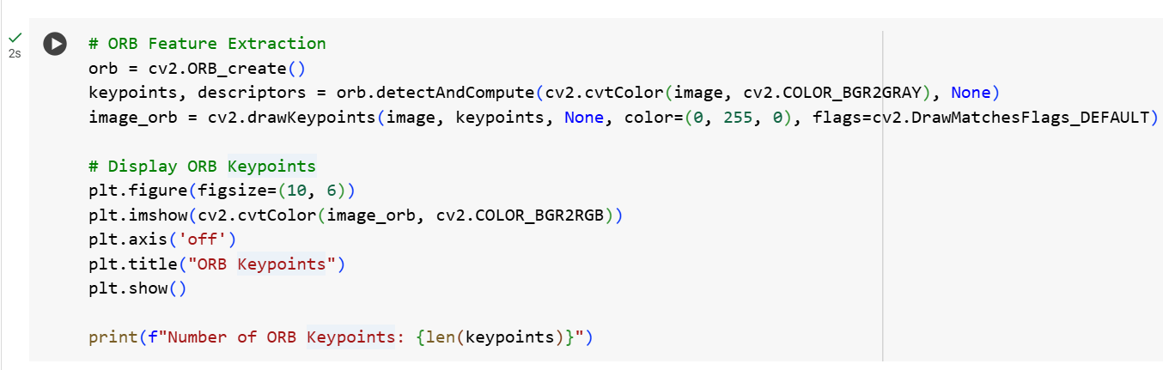

**Output:**

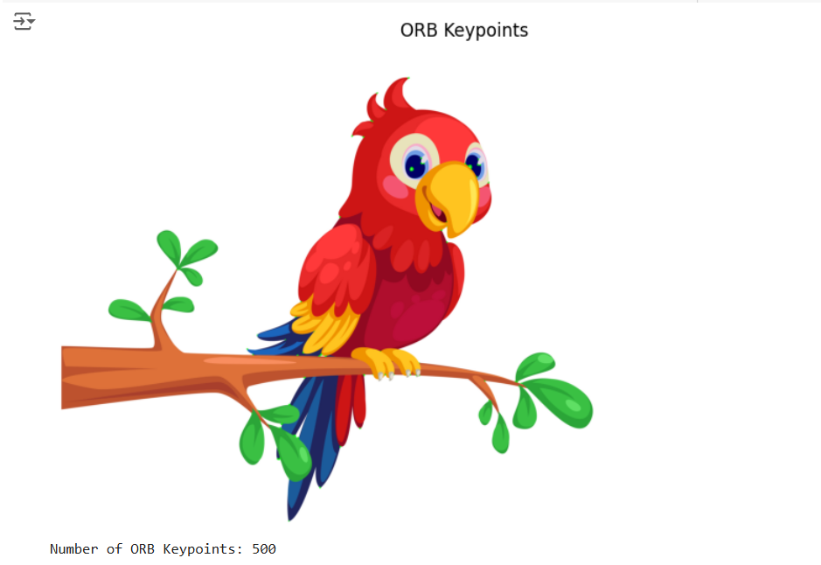

### ****Conclusion****

Feature extraction is a crucial step in machine learning, where raw data is transformed into meaningful attributes that can be used for analysis and model building. The four feature extraction techniques implemented in this project **RGB color feature extraction, color histogram, HOG, and ORB** are fundamental methods for analyzing images. These features help capture the overall color composition, distribution of color intensities, edge/shape information, and describing keypoints with rotation and scale invariance, respectively, making them valuable for image classification, retrieval, and object detection tasks.